News Release
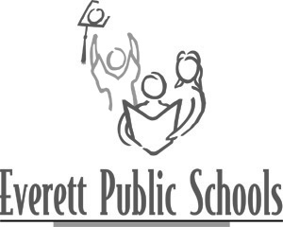
May 20, 2013
For more information:
Mary Waggoner, 425-385-4049
Brian Day, STEM-Science Curriculum Specialist, 425-385-4675

STEM Curriculum Open House for Everett Public Schools
Biotechnology course to be offered at Cascade, Everett and H.M. Jackson high schools in 2013-14 school year

On Thursday, May 23 from 4-7 p.m. in the Career Center (located at Cascade High School) there will be a public viewing of the curriculum being adopted for the biotechnology course that will be offered at three high schools in the Everett School District in the 2013-14 school year. The text book they will be using is: Biotechnology: Science for the New Millennium by Ellyn Daugherty.

There will also be a second viewing at the May 28 school board meeting.

